Decision Support Tool (DST)

Software Version 1.1.921

User Guide



March 2020

Department of Veterans Affairs

Office of Information and Technology (OIT)

Revision History

NOTE: The revision history cycle begins once changes or enhancements are requested after the document has been baselined.

| Date | Revision | Description | Author |
| --- | --- | --- | --- |
| 03/12/2020 | 7.0 | Software Version 1.1.921:   * Updated screen captures. * Updated Best Medical Interest of Veteran menu options. * Added Explanation field for Best Medical Interest of Veteran options. * Added a note and screen capture for No Basic Eligibility Found in Enrollment System. * Updated the Urgency section. * Removed No Later Than Date from Provider workflow. * Removed Special Instructions. * No Later Than Date was renamed to Wait Time Eligibility Date in the VCCPE-Admin workflow. * Added note that VCCPE Wait Time Eligibility is not applicable when CID is greater than Wait Time Eligibility Date. | AbleVets |
| 11/25/2019 | 6.0 | Software Version 1.1:   * Updated screen captures. * Updated acronym list. * Added character limit note to the Explanation field under the Best Medical Interest of Veteran section. * Added What’s New? Screen to DST login. * Added Best Medical Interest of Veteran note for signed consult. * Updated Best Medical Interest of Veteran menu options. * Added Capturing Scheduling Information in the VCCPE-Admin Workflow section. * Added Auto-Forward Consult to Community Care features   Removed the Link DST Data Dialog Box | AbleVets |
| 08/06/2019 | 5.0 | Software Version 1.0.12:   * Updated screen captures. * Added What’s New? feature information. | AbleVets |
| 07/16/2019 | 4.0 | Software Version 1.0.09:  Added note regarding the Average Drive Time and Average Wait Time not showing up for Clinical Services that require a manual entry. | AbleVets |
| 05/30/2019 | 3.0 | Software Version 1.0.04:   * Updated name from National Service Desk to Enterprise Service Desk. * Updated the Facility Name description to include the radius for Specialty Care and Primary Care. | AbleVets |
| 05/21/2019 | 2.0 | GMRC*3*129:   * Updated VA Facility search radius to 100 miles. * Updated DST dashboard screens. | AbleVets |
| 04/10/2019 | 1.0 | Initial Documentation Release for DST v1.0.03. | AbleVets |

**Artifact Rationale**

Per the Veteran-focused Integrated Process (VIP) Guide, the User’s Guide is required to be completed prior to Critical Decision Point #2 (CD2), with the expectation that it will be updated as needed. A User Guide is a technical communication document intended to give assistance to people using a particular system, such as VistA end users. It is usually written by a technical writer, although it can also be written by programmers, product or project managers, or other technical staff. Most user guides contain both a written guide and the associated images. In the case of computer applications, it is usual to include screenshots of the human-machine interfaces, and hardware manuals often include clear, simplified diagrams. The language used is matched to the intended audience, with jargon kept to a minimum or explained thoroughly. The User Guide is a mandatory, build-level document, and should be updated to reflect the contents of the most recently deployed build. The sections documented herein are required if applicable to your product.

Table of Contents

1. Introduction 1

1.1. Purpose 1

1.2. Document Orientation 1

1.2.1. Organization of the Manual 2

1.2.2. Assumptions 2

1.2.3. Coordination 2

1.2.4. Disclaimers 2

1.2.4.1. Software Disclaimer 2

1.2.4.2. Documentation Disclaimer 3

1.2.5. Documentation Conventions 3

1.2.6. References and Resources 3

1.3. Enterprise Service Desk and Organizational Contacts 3

2. System Summary 4

2.1. System Configuration 4

2.2. Data Flows 5

2.3. User Access Levels 5

2.4. Continuity of Operation 5

3. Getting Started 5

3.1. Logging On 5

3.2. System Menu 6

3.2.1. Provider DST Dashboard Screen Example 6

3.2.2. Admin VCCPE DST Dashboard Screen Example 10

3.2.3. DST Dashboard Controls 14

3.3. Exit System 15

4. Using the Software 15

4.1. Launching DST 15

4.1.1. Launching DST from an Unsigned Consult or When Ordering a New Consult 16

4.1.2. Launching DST from Add Comments to Consult 19

4.2. Capturing Information in DST 21

4.2.1. Capturing Provider and Veteran Decision Data 21

4.2.2. Capturing Scheduling Information in the VCCPE-Admin Workflow 26

5. Troubleshooting 31

5.1. Unable to Lookup Clinical Service 31

5.2. MVI Error Handling 32

5.3. Enrollment System (ES) Error Handling 33

5.4. PPMS Error Handling 34

6. Acronyms and Abbreviations 35

List of Figures

Figure 1: DST Business Process Workflow – Unsigned Order Consult 4

Figure 2: DST Business Process Workflow – Signed Order Consult 4

Figure 3: CCAD DST Data Flow Diagram 5

Figure 4: Provider DST Dashboard Screen Example 6

Figure 5: No Basic Eligibility Found in Enrollment System Message 8

Figure 6: Best Medical Interest of Veteran Menu Options 9

Figure 7: Admin VCCPE DST Dashboard Screen Example 10

Figure 8: No Basic Eligibility Found in Enrollment System Message 13

Figure 9: Wait Time Eligibility Not Applicable Message 13

Figure 10: DST Dashboard Controls 14

Figure 11: DST: What’s New? Window Example 14

Figure 12: DST Help Window Example 15

Figure 13: Order a Consult 16

Figure 14: MISSION Act Support Message 17

Figure 15: MISSION Act Requires DST Message 17

Figure 16: DST: What’s New? Screen 18

Figure 17: Unsigned Consult/Ordering a New Consult: DST Dashboard Example 19

Figure 18: Consult Toolbox Menu 20

Figure 19: DST: What’s New? Screen 20

Figure 20: DST Dashboard for a Signed Consult 21

Figure 21: Standardized Episode of Care Section 22

Figure 22: Auto-Forward Consult to Community Care Section 22

Figure 23: Auto-Forward Consult to Community Care Not Available Message 22

Figure 24: Populated DST 23

Figure 25: DST Save Success Message 23

Figure 26: Missing Required Fields Message 23

Figure 27: DST Save Failed Error Message 24

Figure 28: CPRS Order a Consult Window: DST Data Displayed in Reason for Request Field 24

Figure 29: DST Data Displayed in Consult Details 25

Figure 30: Admin: DST Dashboard 26

Figure 31: Clinical Service Selected 27

Figure 32: Wait Time Eligible 28

Figure 33: DST Save Success Message 28

Figure 34: Missing Required Fields Message 29

Figure 35: DST Save Failed Error Message 29

Figure 36: CPRS Order a Consult Window: DST Data Displayed in Reason for Request Field 30

Figure 37: Admin: DST Data Displayed in Consult Details 30

Figure 38: Manual Selection of Clinical Service 31

Figure 39: Veteran Identity Error Handling 32

Figure 40: Veteran Eligibility Error Handling 33

Figure 41: VA Facilities Error Handling 34

# Introduction

The Veterans Health Administration (VHA) Office of Community Care has a need for a real-time decision support tool to help Department of Veterans Affairs (VA) Providers and Veterans quickly review the criteria proscribed in the VA MISSION Act of 2018, determine whether a given Veteran is eligible and would be best served utilizing the Veterans Community Care Program, and document the decision rationale in the Veteran’s health record.

The Decision Support Tool (DST) software will:

* Allow the user to view relevant data within the existing Computerized Patient Record System (CPRS) consult order workflow, that helps the Veteran and VA provider decide if a consult service should be referred to the local VA facility, a near-by VA facility via Inter-Facility Consults (IFC), or to a community provider by providing information about the following:
* Drive time standards associated with the requested consult service.
* Average wait times for the requested clinical service at VA facilities near the Veteran’s place of residence. Note, the average wait times may not be used to determine wait time eligibility.
* Veteran’s eligibility for accessing care in the community and their stated preferences (opt-in/out)
* Allow the provider to select the consult decision and enter additional justification text when indicated.
* Based on the decision outcome, provide required information to the Electronic Medical Record (EMR) in order to initiate either an in-house, IFC, or Veteran Community Care Program (VCCP) consult order.
* Document the rationale for the referral decision in the consult record.
* Generate structured text based on the displayed results that can be used for downstream report generation.

## Purpose

The purpose of this document is to provide instruction for utilizing the DST to standardize and streamline consult management for Community Care.

## Document Orientation

The *Decision Support Tool User Guide* will provide explanations of each screen and of all user interface options within the context of an easy to understand demonstration data scenario.

This document is also designed to provide the user with screen-by-screen “how to” information on the usage of Consult Toolbox.

### Organization of the Manual

**Section 1: Introduction**

The Introduction section provides the purpose of this manual, an overview of the DST software, an overview of the software used, project references, contact information for the user to seek additional information, and an acronyms and abbreviations list for this manual.

**Section 2: System Summary**

The System Summary section provides a graphical representation of the equipment, communication, and networks used by the system, user access levels, how the software will be accessed, and contingencies and alternative modes of operation.

**Section 3: Getting Started**

Information for the Getting Started section provides a general walk-through of the system from initiation through exit, enabling the user to understand the sequence and flow of the system.

**Section 4: Using the Software**

This section gives the user the “how to” information to use DST, including many step-by-step procedures.

**Section 5: Troubleshooting**

This section provides troubleshooting for the DST user.

**Section 6: Acronyms and Abbreviations**

This section provides a list of acronyms and abbreviations found in this document.

### Assumptions

This guide was written with the following assumed experience/skills of the audience:

* User has login credentials for CPRS.
* User has basic knowledge of the CPRS operating system (such as the use of commands, menu options, and navigation tools).
* User has Consult Toolbox v1.9.0054 or later installed on their machine.
* User has Google Chrome installed on their machine.

### Coordination

N/A

### Disclaimers

#### Software Disclaimer

This software was developed at the Department of Veterans Affairs (VA) by employees of the Federal Government in the course of their official duties. Pursuant to title 17 Section 105 of the United States Code this software is not subject to copyright protection and is in the public domain. VA assumes no responsibility whatsoever for its use by other parties, and makes no guarantees, expressed or implied, about its quality, reliability, or any other characteristic. We would appreciate acknowledgement if the software is used. This software can be redistributed and/or modified freely provided that any derivative works bear some notice that they are derived from it, and any modified versions bear some notice that they have been modified.

#### Documentation Disclaimer

The appearance of external hyperlink references in this manual does not constitute endorsement by the Department of Veterans Affairs (VA) of this Web site or the information, products, or services contained therein. The VA does not exercise any editorial control over the information you may find at these locations. Such links are provided and are consistent with the stated purpose of the VA.

### Documentation Conventions

This manual uses several methods to highlight different aspects of the material.

Table 1. Documentation Symbols and Descriptions

|  |  |
| --- | --- |
| Symbol | Description |
| Triangle with an exclamation point (!) inside to indicate caution for the reader to take special notice of critical information. | **CAUTION:** Used to caution the reader to take special notice of critical information. |

1. Notes are used to inform the reader of general information including references to additional reading material.

### References and Resources

Readers who wish to learn more about DST, Consult Toolbox, and CPRS should consult the following:

* CPRS: Consult/Request Tracking in the VDL: <https://www.va.gov/vdl/application.asp?appid=62>
* Office of Community Care Field Guidebook: https://dvagov.sharepoint.com/sites/VHAOCC/CNM/CI/OCCFGB/SitePages/FGB.aspx

## Enterprise Service Desk and Organizational Contacts

For issues related to the Community Care DST that cannot be resolved by this manual or the site administrator, please contact the Enterprise Service Desk at 855-NSD-HELP (673-4357).

# System Summary

## System Configuration

Within the current CPRS order consult workflow, VA providers utilize the DST system to support the decision and election for consult services for a given consult.

Figure 1: DST Business Process Workflow – Unsigned Order Consult

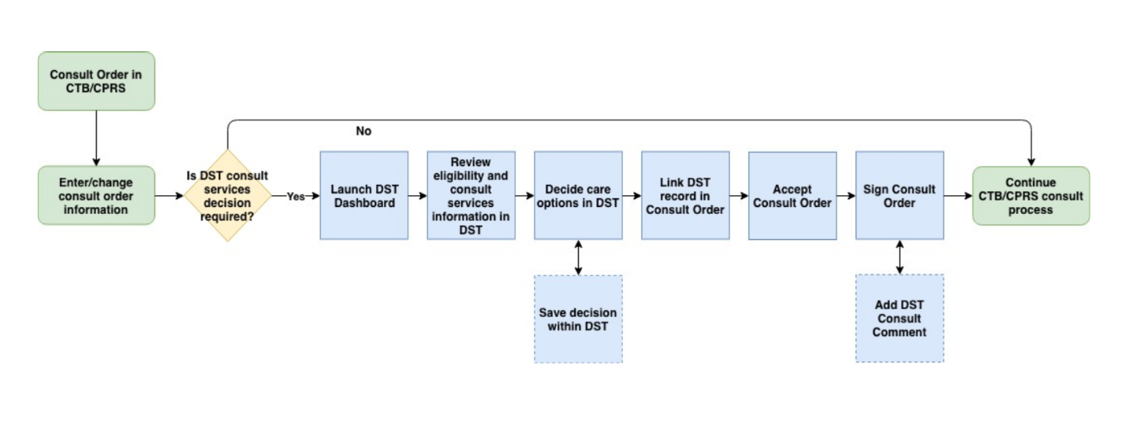

Figure 2: DST Business Process Workflow – Signed Order Consult

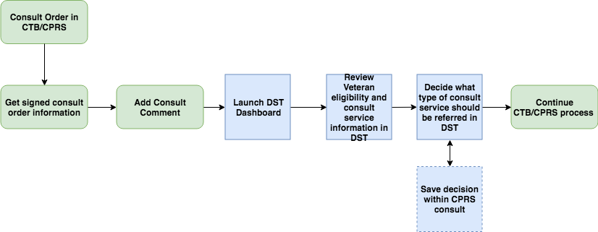

## Data Flows

Figure 3: CCAD DST Data Flow Diagram

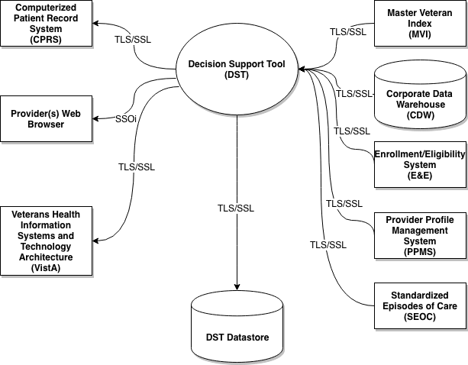

## User Access Levels

All VA providers will serve as the main user base for this system. The user must have access to CPRS and Consult Toolbox must be enabled to access DST.

## Continuity of Operation

DST falls under the Veterans Health Information Systems and Technology Architecture (VistA) Continuity of Operations Plan.

# Getting Started

This section provides a general walkthrough of DST from initiation through exit.

## Logging On

DST is accessed through CPRS.

1. If you have Consult Toolbox v1.9.0054 installed, you will no longer see the standard VA-provided Single Sign-On Integration (SSOi) page when launching DST from CPRS.

## System Menu

The DST Dashboard features three sections: **Consult**, **VA Facilities**, and **Community Care**. The fields

### Provider DST Dashboard Screen Example

Figure 4: Provider DST Dashboard Screen Example

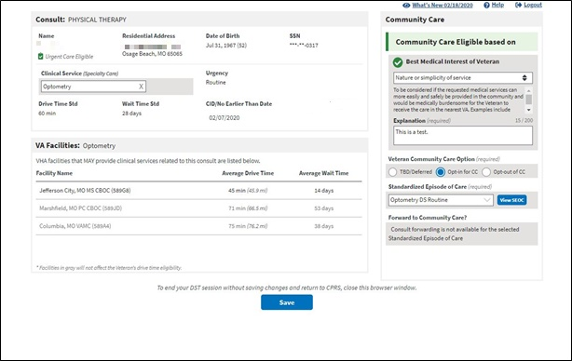

Following are descriptions of the features on the DST Dashboard.

**Consult** section:

* **Name** – Veteran name. This is a read only field supplied by CPRS.
* **Residential Address** – Veterans residential address. This is a read only field supplied by the Master Veteran Index (MVI) data interface. Provided by Eligibility & Enrollment System.
* **Date of Birth** – Veterans date of birth. This is a read only field supplied by CPRS.
* **SSN** – Veterans Social Security Number (SSN). This is a read only field supplied by CPRS.
* **Clinical Service** – Consult Clinical Service. Automatically assigned when the user launches DST from CPRS or this field can be manually entered, it depends if you are using an unsigned or signed consult.
* **Urgency** – This is a read only field supplied by CPRS.
* **Routine** – A Routine consult indicates the patient should be seen in accordance with the clinically indicated date.
* **Stat** – Stat consults will be defined as an “immediate” need. The sender of a stat consult is required to:
  + - Contact the intended receiver of the consult request to discuss the patients’ situation.
    - A stat consult must be completed within 24 hours.
* **Drive Time Std** – This is a read only field supplied by local DST datastore, based on whether the selected clinical service is considered Primary Care/Mental Health or Specialty Care.
* **Wait Time Std** – This is a read only field supplied by local DST datastore, based on whether the selected clinical service is considered Primary Care/Mental Health or Specialty Care.
* **CID/No Earlier Than Date** – This is a read only field auto-populated from CPRS.

**VA Facilities** section: VHA facilities that MAY provide clinical related to this consult are listed in this section. DST searches an internal table (updated weekly from Corporate Data Warehouse (CDW)) to filter the returned list to facilities within a 100-mile radius for Specialty Care consults (40-mile radius for Primary Care/Mental Health) that offer services associated with consult Clinical Service (based on the National IFC Dashboard).

1. Average Drive Time and Average Wait Time will not show up until a Clinical Service has been selected, whether by default or via manual entry. The DST application attempts to map consult names to Clinical Services for all Nationwide sites. However, due to the distributed and dynamic nature of consult name addition by the local VA site, DST is not able to keep a real time list of these Consult to Clinical Service mappings. When DST application cannot find a Consult to Clinical Service mapping, the application requires that the user enter the Clinical Service manually on the DST dashboard. When this clinical service is entered, the DST application will continue to request and populate the facility drive time and average wait time based on Residential Address and the entered clinical service.
2. DST may display facilities that are outside the drive time standard so that the Veteran is aware of VA facility options. Facilities displayed that are outside the drive time standard, are not used in the drive time eligibility calculation and will appear in gray text.

* **Facility Name** – List of VHA facilities that offer a related consult service within a 100-mile radius for Specialty Care and a 40-mile radius for Primary Care of the Veteran residential address (sorted by Average Drive Time low-to-high).
* **Average Drive Time** – This refers to the average time it takes to drive from the Veteran’s residential address as noted in the Enrollment System to each identified VA facility that may offer the requested service. This measurement uses VA’s Provider Profile Management System (PPMS) which is a Microsoft-based product that utilizes Bing maps and a proprietary algorithm to determine the time to drive between the two addresses. If PPMS returns 10 facilities or fewer, the drive time calculation takes into account distance, route, speed limits and historical traffic pattern data. If PPMS returns more than 10 facilities, historical traffic data will be excluded from the drive time calculation.
* **Average Wait Time –** This is measured as the average time from the date an appointment is created to the date of the appointment itself. DST displays the average wait times of all new patient appointments completed in the stop code of the requested clinical service, based on new patient appointments in a rolling 30-day assessment. It is possible a facility offers the service requested but has not had any new patients in the last 30 days. In this case, the Average Wait Time field will state Data Not Available. This calculation is similar to the method used for the VA Access to Care public facing website.

It is important to note that average wait time in DST should be used only for reference. It will not be used to establish Community Care eligibility. Community Care wait time eligibility is determined at the time of scheduling the appointment, not at the time of requesting it.

**Community Care** section: If DST receives a unique Veteran Integration Control Number (ICN) back from MVI, it sends the ICN to the Enrollment System (ES) Application Program Interface (API) to retrieve the Veteran’s residential address and a Veterans eligibility identifying string containing one or more of the following eligibility codes applicable to DST: “U” – Urgent care eligible, “G” – Grandfathered, “H” – Hardship, or “N” – No full-service VHA facility.

* **Community Care Eligible based on -**
* **Enrollment System Basic Eligibility Factor** - If a Veteran is designated in the Enrollment System as ineligible for Community Care, DST will now display a message indicating that the Veteran is ineligible for Community Care because they lack Basic eligibility. If the Veteran lacks Basic eligibility, you will not be able to edit any information on the DST dashboard and you will not be able to establish Community Care eligibility for this Veteran. When you have reviewed the Veteran information in DST, save the DST record to document the Community Care ineligible status for the Veteran. This affects patients eligible for VA care but not otherwise eligible for Community Care, such as Civilian Health and Medical Program of the Department of Veterans Affairs (CHAMPVA) patients being seen at the VAMC under the CHAMPVA In-house Treatment Initiative (CITI) program.

Figure 5: No Basic Eligibility Found in Enrollment System Message

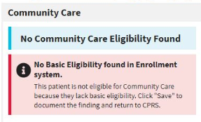

* Enrollment System Eligibility Factors – **Hardship**, **Grandfathered**, or **No Full Service VHA**. If any of the indicators are received from the enrollment system, the Veteran will be identified as eligible for Community Care.
* **Drive Time** – If there are no facilities listed within the drive time standard for the selected clinical service, then the Veteran will be identified as eligible for Community Care based on drive time.
* **Best Medical Interest of Veteran** – Drop-down menu. There is a Community Care policy and procedure that allows a VA provider to request the ability for a Veteran to receive care in the community based on that Veterans best medical interest. Congress requests that VA providers consider: **Nature or simplicity of service**, **Frequency of service**, **Need for an attendant**, **Potential for improved continuity of care**, or **Difficulty in traveling**.

1. The Best Medical Interest of Veteran drop-down menu will only display when DST is launched from an unsigned consult if the Veteran is not otherwise eligible.

Figure 6: Best Medical Interest of Veteran Menu Options

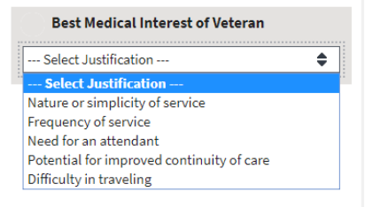

* + - **Nature or simplicity of service**
    - **Frequency of service**
    - **Need for an attendant**
    - **Potential for improved continuity of care**
    - **Difficulty in traveling**
    - **Explanation (required)** field – This field displays once a selection has been made from the **Best Medical Interest of Veteran** drop-down menu. This information will be saved to the consult and is captured for reporting purposes. (This field has a maximum 200-character limit.)
* **Veteran Community Care Option (required)** –
* **TBD/Deferred** – When this radio button is selected it will require a Standardized Episodes of Care (SEOC) to be selected if the Veteran ultimately opts in to Community Care. Because a SEOC is required on every consult that goes to Community Care, this allows the ordering provider to select the appropriate SEOC to match the consult/order that is being ordered at the time it is placed. Additionally, it allows the creator of the consult and thus user of the DST to use information even if the Veteran is a) Not ready to decide or b) Not present. This button then enables the provider to ask a team member to finish the opt in/out decision later while maintaining the integrity of the initial DST dashboard information.
* **Opt-In for CC** – Veteran elects care in the community.
* **Opt-out of CC** – Veteran elects to remain within the VA for care.
* **Standardized Episode of Care (required)** – Relates to Clinical Service. A service or group of services the VA authorizes a community provider to perform to complete the consult order including the duration and number of visits that might be necessary. Some or all of the authorized services may need to be performed during any particular episode of care.
* **Forward Consult to Community Care?** – Option to automatically forward consult to Community Care when order is signed.
* **Yes**
* **No**

### Admin VCCPE DST Dashboard Screen Example

Figure 7: Admin VCCPE DST Dashboard Screen Example

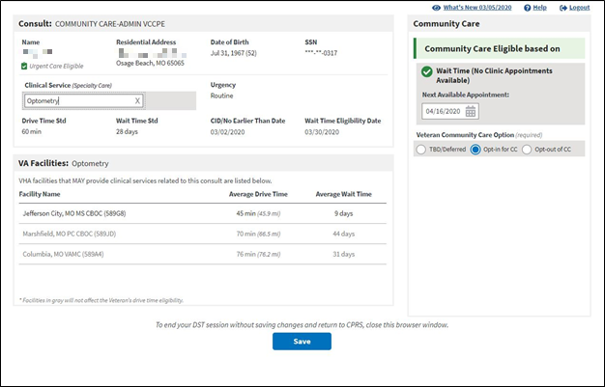

Following are descriptions of the features on the DST Dashboard.

**Consult** section

* **Name** – Veteran name. This is a read only field supplied by CPRS.
* **Residential Address** – Veterans residential address. This is a read only field supplied by the MVI data interface. Provided by Eligibility & Enrollment System.
* **Date of Birth** – Veterans date of birth. This is a read only field supplied by CPRS.
* **SSN** – Veterans Social Security Number (SSN). This is a read only field supplied by CPRS.
* **Clinical Service** – Consult Clinical Service. Automatically assigned when the user launches DST from CPRS or this field can be manually entered, it depends if you are using an unsigned or signed consult.
* **Urgency** – This is a read only field supplied by CPRS.
* **Routine** – A Routine consult indicates the patient should be seen in accordance with the clinically indicated date.
* **Stat** – Stat consults will be defined as an “immediate” need. The sender of a stat consult is required to:
  + - Contact the intended receiver of the consult request to discuss the patients’ situation.
    - A stat consult must be completed within 24 hours.
* **Drive Time Std** – This is a read only field supplied by local DST datastore, based on whether the selected clinical service is considered Primary Care/Mental Health or Specialty Care.
* **Wait Time Std** – This is a read only field supplied by local DST datastore, based on the urgency and whether the selected clinical service is considered Primary Care/Mental Health or Specialty Care.

|  |  |  |
| --- | --- | --- |
| Urgency | Type | Wait Time Standard |
| Routine | Primary Care/Mental Health | 28 days |
| Routine | Specialty Care | 20 days |
| Stat | Primary Care/Mental Health or Specialty Care | 1 day |

* **CID/No Earlier Than Date** – This is a read only field auto-populated from CPRS.
* **Wait Time Eligibility Date** – This date is calculated as Today + wait time standard. See additional wait time eligibility details in the *Office of Community Care Field Guidebook*.

**VA Facilities** section: VHA facilities that MAY provide clinical related to this consult are listed in this section. DST searches an internal table (updated weekly from Corporate Data Warehouse (CDW)) to filter the returned list to facilities within a 100-mile radius for Specialty Care consults (40-mile radius for Primary Care/Mental Health) that offer services associated with consult Clinical Service (based on the National IFC Dashboard).

1. Average Drive Time and Average Wait Time will not show up until a Clinical Service has been selected, whether by default or via manual entry. The DST application attempts to map consult names to Clinical Services for all Nationwide sites. However, due to the distributed and dynamic nature of consult name addition by the local VA site, DST is not able to keep a real time list of these Consult to Clinical Service mappings. When DST application cannot find a Consult to Clinical Service mapping, the application requires that the user enter the Clinical Service manually on the DST dashboard. When this clinical service is entered, the DST application will continue to request and populate the facility drive time and average wait time based on Residential Address and the entered clinical service.
2. DST may display facilities that are outside the drive time standard so that the Veteran is aware of VA facility options. Facilities displayed that are outside the drive time standard, are not used in the drive time eligibility calculation and will appear in gray text.

* **Facility Name** – List of VHA facilities that offer a related consult service within a 100-mile radius for Specialty Care and a 40-mile radius for Primary Care of the Veteran residential address (sorted by Average Drive Time low-to-high).
* **Average Drive Time** – This refers to the average time it takes to drive from the Veteran’s residential address as noted in the Enrollment System to each identified VA facility that may offer the requested service. This measurement uses VA’s Provider Profile Management System (PPMS) which is a Microsoft-based product that utilizes Bing maps and a proprietary algorithm to determine the time to drive between the two addresses. If PPMS returns 10 facilities or fewer, the drive time calculation takes into account distance, route, speed limits and historical traffic pattern data. If PPMS returns more than 10 facilities, historical traffic data will be excluded from the drive time calculation.
* **Average Wait Time –** This is measured as the average time from the date an appointment is created to the date of the appointment itself. DST displays the average wait times of all new patient appointments completed in the stop code of the requested clinical service, based on new patient appointments in a rolling 30-day assessment. It is possible a facility offers the service requested but has not had any new patients in the last 30 days. In this case, the Average Wait Time field will state Data Not Available. This calculation is similar to the method used for the VA Access to Care public facing website.

It is important to note that average wait time in DST should be used only for reference. It will not be used to establish Community Care eligibility. Community Care wait time eligibility is determined at the time of scheduling the appointment, not at the time of requesting it.

**Community Care** section: If DST receives a unique Veteran ICN back from MVI, it sends the ICN to the Enrollment System (ES) API to retrieve the Veteran’s residential address and a Veterans eligibility identifying string containing one or more of the following eligibility codes applicable to DST: “U” – Urgent care eligible, “G” – Grandfathered, “H” – Hardship, or “N” – No full-service VHA facility.

* **Community Care Eligible based on** –
* **Enrollment System Basic Eligibility Factor** - If a Veteran is designated in the Enrollment System as ineligible for Community Care, DST will now display a message indicating that the Veteran is ineligible for Community Care because they lack Basic eligibility. If the Veteran lacks Basic eligibility, you will not be able to edit any information on the DST dashboard and you will not be able to establish Community Care eligibility for this Veteran. When you have reviewed the Veteran information in DST, save the DST record to document the Community Care ineligible status for the Veteran. This affects patients eligible for VA care but not otherwise eligible for Community Care, such as Civilian Health and Medical Program of the Department of Veterans Affairs (CHAMPVA) patients being seen at the VAMC under the CHAMPVA In-house Treatment Initiative (CITI) program.

Figure 8: No Basic Eligibility Found in Enrollment System Message



* **Wait Time Eligibility Not Applicable** – If the CID is further in the future than the Wait Time Eligibility Date, then Wait Time Eligibility is not applicable for the consult and the following warning will display.

Figure 9: Wait Time Eligibility Not Applicable Message

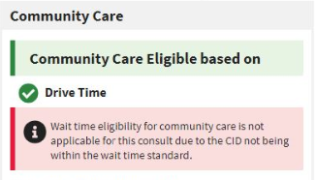

* Enrollment System Eligibility Factors – **Hardship**, **Grandfathered**, **No Full Service VHA**. If any of the indicators are received from the enrollment system, the Veteran will be identified as eligible for Community Care.
* **Drive Time** – If there are no facilities listed within the drive time standard for the selected clinical service, then the Veteran will be identified as eligible for Community Care based on drive time.
* **Wait Time (No Clinic Appointments Available) –** If the date entered in the Next Available Appointment field is greater than the Wait Time Eligibility Date, then the Veteran will be identified as eligible for Community Care based on wait time.
* **Veteran Community Care Option (required)** –
* **TBD/Deferred** – When this radio button is selected it will require a Standardized Episodes of Care (SEOC) to be selected if the Veteran ultimately opts-in to Community Care. Because a SEOC is required on every consult that goes to Community Care, this allows the ordering provider to select the appropriate SEOC to match the consult/order that is being ordered at the time it is placed. Additionally, it allows the creator of the consult and thus user of the DST to use information even if the Veteran is a) Not ready to decide or b) Not present. This button then enables the provider to ask a team member to finish the opt in/out decision later while maintaining the integrity of the initial DST dashboard information.
* **Opt-In for CC** – Veteran elects care in the community.
* **Opt-out of CC** – Veteran elects to remain within the VA for care.

### DST Dashboard Controls

The DST Dashboard Controls are located at the top right of the DST Dashboard screen.

Figure 10: DST Dashboard Controls



* **What’s New?** – Click **What’s New?** to open the **DST: What’s New?** window. This window lists the new features for each release/build.

Figure 11: DST: What’s New? Window Example

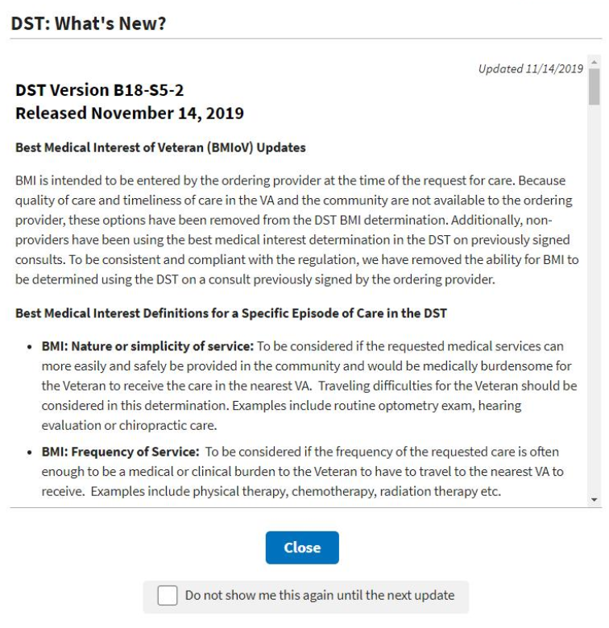

* **Help** – Click **Help** to open a window offering resources for answering questions.

Figure 12: DST Help Window Example

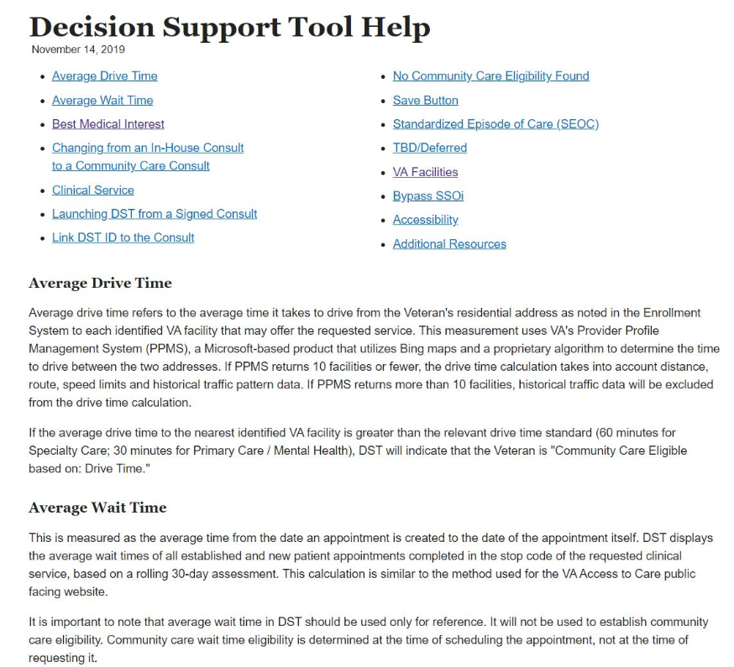

* **Logout** – Click **Logout** to exit out of DST.

## Exit System

To exit DST, click **Logout** at the upper right corner of your screen. To end your DST session without saving changes and return to CPRS, close the browser window.

# Using the Software

## Launching DST

DST can be accessed the following ways:

* Accessing the Decision Support Tool via an Unsigned Consult
* Accessing the Decision Support Tool when Ordering a New Consult
* Accessing the Decision Support Tool via Adding a Comment in a Signed Consult

1. When launched, DST will determine if the consult should be opened in the Provider workflow or the Veteran Community Care Program Eligibility (VCCPE)-Admin workflow.

The sections below provide additional information regarding how to launch DST.

1. All examples in this document are representative of test data, no patient Personally Identifiable Information (PII) was used.

### Launching DST from an Unsigned Consult or When Ordering a New Consult

DST can be launched from the **Order a Consult** dialog box from an unsigned consult and when ordering a new consult. When the CPRS window titled **Order a Consult** is active and populated as an outpatient consult without a DST ID already in the Reason for Request, Consult Toolbox displays a message over the **Accept Consult** button while it sends the Consult to Service/Specialty name to DST to determine if the consult is applicable to the MISSION Act.

DST searches an internal table (updated nightly from CDW) to determine whether the Clinical Service associated with the consult requires DST and returns the result to Consult Toolbox.

If DST returns FALSE, no action is initiated by Consult Toolbox and the consult order workflow continues uninterrupted. If DST returns TRUE or a previous DST ID is found in the Reason for Request field, Consult Toolbox displays a movable, non-modal window to inform the user that the consult should be reviewed for eligibility under the MISSION Act and allows them to open the DST prior to accepting the consult.

Figure 13: Order a Consult

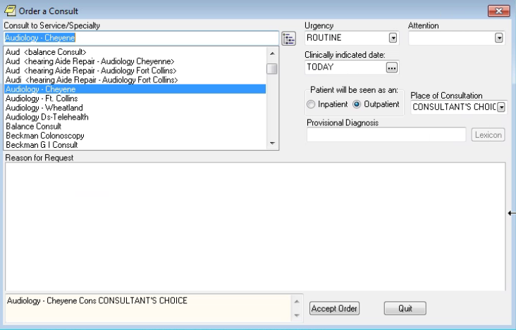

To launch DST from **Order a Consult**, follow the steps listed below:

1. From the **Order a Consult** window, select an option from the **Consult to Service/Specialty**. If **Outpatient** is selected, then a message stating that it is checking to see if the consult requires MISSION Act support displays.

Figure 14: MISSION Act Support Message

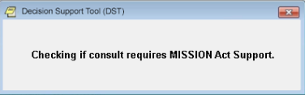

If MISSION Act requires the use of the DST, a message will display.

Figure 15: MISSION Act Requires DST Message

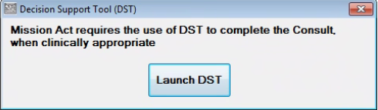

1. Click **Launch DST**. The **DST: What’s New? Screen** displays.

Figure 16: DST: What’s New? Screen



1. If you do not want the DST: What’s New? window to display each time you launch DST, select the **Do not show me this again until the next update** checkbox and the window will only display where there are new DST updates.
2. Click **Close**. The **DST Dashboard** displays.

Figure 17: Unsigned Consult/Ordering a New Consult: DST Dashboard Example

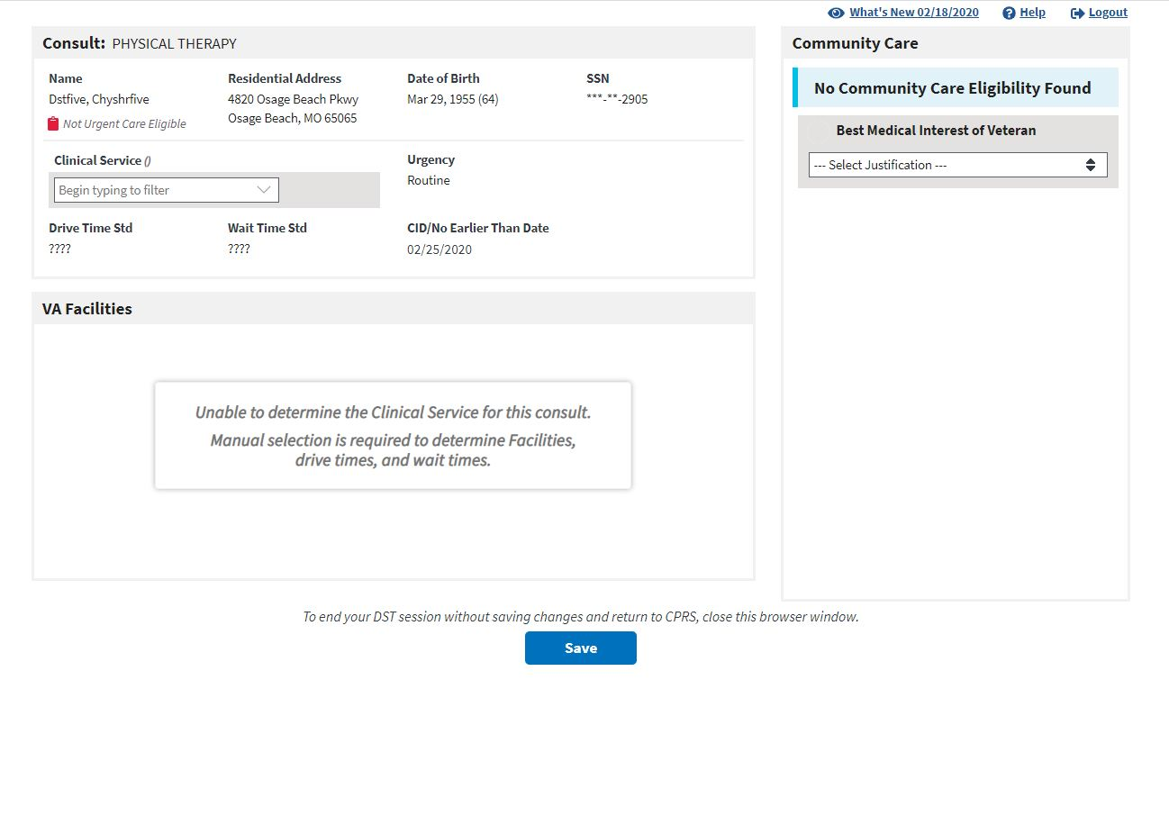

### Launching DST from Add Comments to Consult

DST can be accessed from the Consult Toolbox menu that is displayed when you right-click inside the Add Comment to Consult window in CPRS. When DST is launched this way, the user input data is carried-forward from the most recent DST data set if present.

DST Data is kept in the local database for a period of 30 days after the last update. The data is used to populate the consult comment when the order is signed and to restore the user entries when DST is reopened. If someone opens DST from a consult after the DST data has been deleted, they will see the same as if DST was being opened for the first time on the consult. Eligibility and facility information is always updated in real-time, while the Best Medical Interest of the Veteran, Veteran Community Care Option, SEOC, and Consult Decision will be blank.

To launch DST from Consult Toolbox Add Comment to Consult, follow the steps listed below:

1. From the **Action** menu, select **Consult Tracking…** > **Add Comment**. The **Add Comment to Consult** window displays the Consult Toolbox menu.

Figure 18: Consult Toolbox Menu

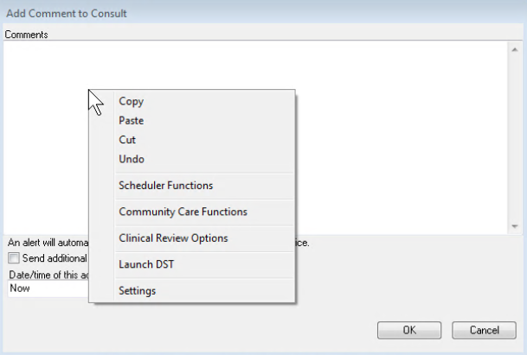

1. From the **Consult Toolbox** menu, select **Launch DST**. The **DST: What’s New? Screen** displays.

Figure 19: DST: What’s New? Screen



1. If you do not want the DST: What’s New? window to display each time you launch DST, select the **Do not show me this again until the next update** checkbox and the window will only display where there are new DST updates.
2. Click **Close**. The **DST Dashboard** displays.

Figure 20: DST Dashboard for a Signed Consult

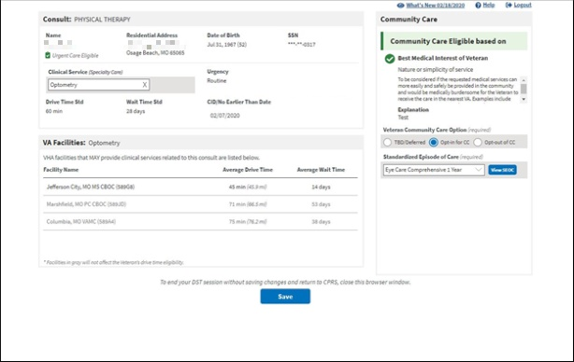

## Capturing Information in DST

### Capturing Provider and Veteran Decision Data

DST allows you to enter additional information required to fully document the decision to order a VA consult or create a Community Care referral. To enter additional information, follow the steps listed below:

1. Under the **Consult** section, verify if the **Clinical Services (Specialty Care)** field has been auto populated. If the consult is mapped to a clinical service, this field will be populated with the mapped value. If this field is not populated, enter/select the appropriate clinical service. The **VA Facilities** section will populate.
2. If there are no other Community Care eligibility factors found and the provider and Veteran have agreed that it is in the Veteran’s best medical interest to be seen in the community during this specific episode of care, under the **Community Care** section, select an option from the **Best Medical Interest of Veteran** drop-down menu to establish eligibility. Once an option is selected, you must provide additional clinical information to support Best Medical Interest (BMI) selection in the **Explanation** field.
3. The **Best Medical Interest of Veteran** option will be read-only when the consult has been signed if the value was previously entered otherwise it is not displayed.
4. If the Veteran is eligible for Community Care, from the **Veteran Community Care Choice** area, select the Veteran’s choice to **TBD/Deferred**, **Opt-in for CC**, or **Opt-out of CC**. If you select the Veteran Community Care Choice of **TBD/Deferred** or **Opt-in for CC**, the **Standardized Episode of Care** section becomes visible.

Figure 21: Standardized Episode of Care Section

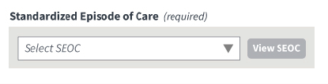

1. If the Veteran is eligible for Community Care and opts-in, from the **Standardized Episode of Care** drop-down menu, select a SEOC to define the authorized care should the consult be forwarded to Community Care. The list of SEOCs is filtered based on the selected Clinical Service (based on government-furnished mapping) to eliminate unrelated SEOCs from the selection list. The SEOC content can be previewed after selection. Once you select the SEOC, the **Forward Consult to Community Care** section becomes visible.

Figure 22: Auto-Forward Consult to Community Care Section

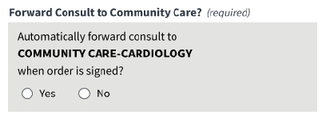

Note, if the selected SEOC is not available for consult forwarding a message will display. Please refer to the DST-Clinical Service Mapping file on the [SharePoint site](https://vaww.vha.vaco.portal.va.gov/DUSHCC/DC/DO/CI/S/Decision%20Support%20Tool/Forms/AllItems.aspx).

Figure 23: Auto-Forward Consult to Community Care Not Available Message

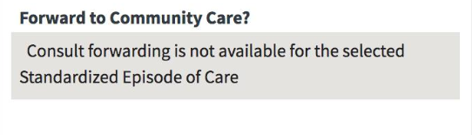

1. DST generates a standard Community Care Consult Name based on the SEOC selected.
2. From the **Forward Consult to Community Care** section, select **Yes** or **No** if you want to automatically forward the consult when the order is signed. If you try to save the DST info before selecting an option, an error message displays prompting you to make the correction before saving.

Figure 24: Populated DST

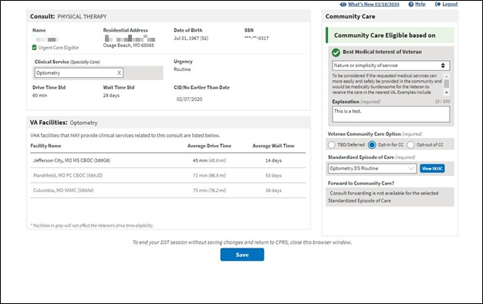

1. Once the required DST information is populated the save button will enabled. Click **Save DST Info**, the **DST Save Success Message** displays. The information captured on the DST dashboard will now be saved to the consult.

Figure 25: DST Save Success Message

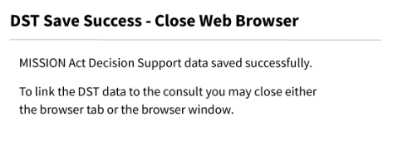

If DST is unable to save due to content missing, the **Unable to Save Message** displays. Update the missing fields and save again.

Figure 26: Missing Required Fields Message

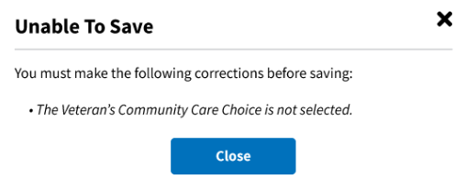

If something went wrong while trying to save, the **DST Save Failed Error Message** displays.

Figure 27: DST Save Failed Error Message

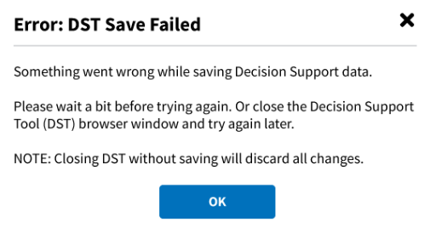

1. To link the DST data to the consult, close the DST Chrome browser tab or close the Chrome browser completely by clicking the **X** in the top right corner. The linked DST data displays in the **Reason for Request** section in the **Order a Consult** window.

Figure 28: CPRS Order a Consult Window: DST Data Displayed in Reason for Request Field

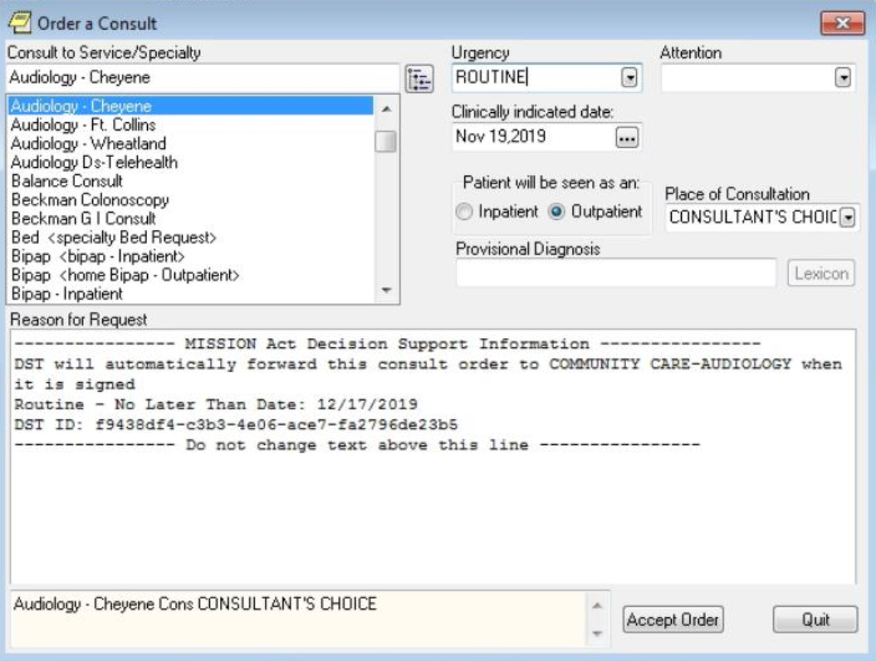

1. Click **Accept Order**. The consult is signed and actual DST information is displayed in the form of a comment. Any changes to DST after a consult is signed will result in a new comment.

Figure 29: DST Data Displayed in Consult Details

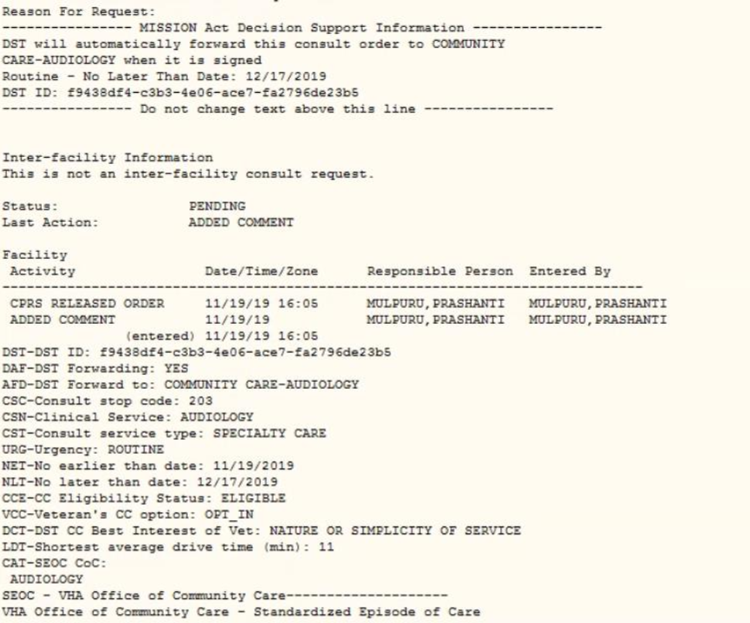

### Capturing Scheduling Information in the VCCPE-Admin Workflow

DST allows you to capture scheduling information in the VCCPE-Admin workflow. To capture the scheduling information, follow the steps listed below:

Figure : Admin: DST Dashboard

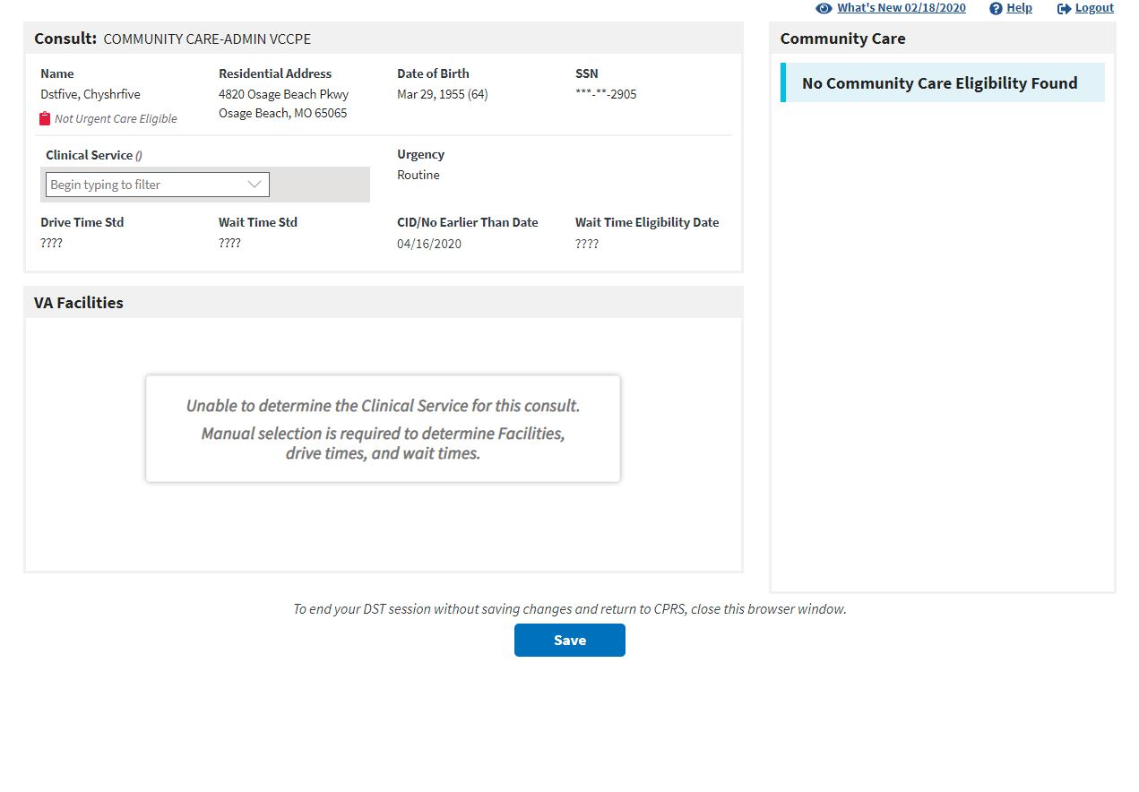

1. Under the **Consult** section, enter/select the **Clinical Services (Specialty Care)** name in the field. The **VA Facilities** section will populate.

Figure : Clinical Service Selected

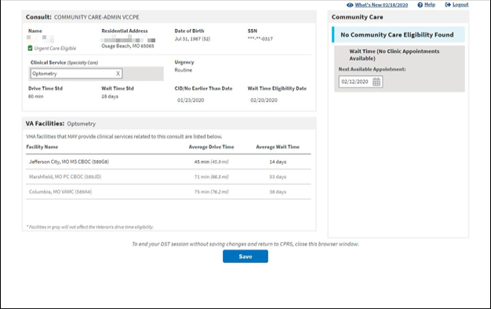

1. Under the **Community Care** section, enter/update the **Next** **Available Appointment** field. If the **Next** **Available Appointment** is updated and is after the **No Later Than Date**, then the patient will be **Wait Time (No Clinic Appointments Available)** eligible for Community Care.

Figure : Wait Time Eligible

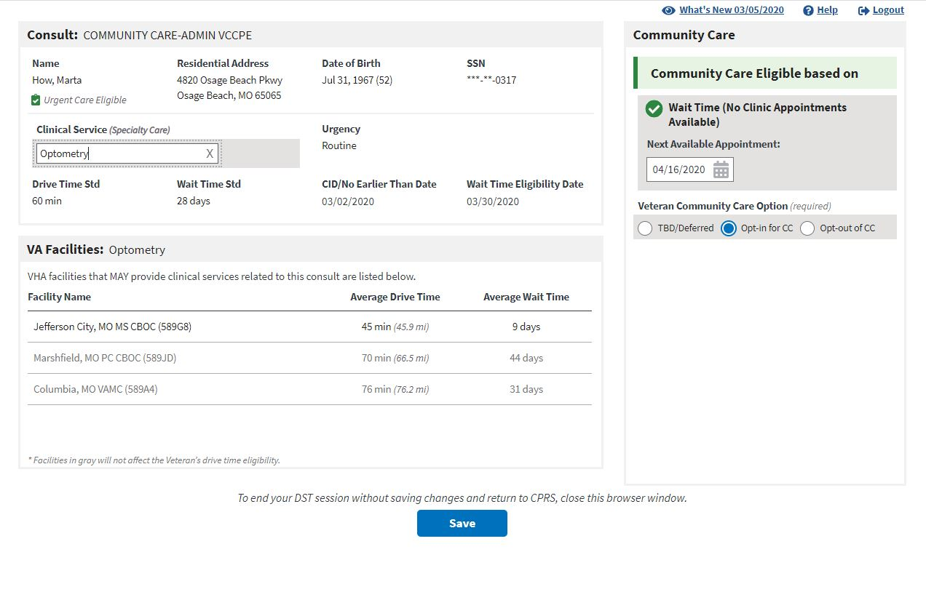

1. If the Veteran is eligible for Community Care, from the **Veteran Community Care Choice** area, select the Veteran’s choice to **TBD/Deferred**, **Opt-in for CC**, or **Opt-out of CC**.
2. Once the required DST information is populated the save button will enabled. Click **Save**, the **DST Save Success Message** displays. The information captured on the DST dashboard will now be saved to the consult.

Figure 33: DST Save Success Message



If DST is unable to save due to content missing, the **Unable to Save Message** displays. Update the missing fields and save again.

Figure 34: Missing Required Fields Message



If something went wrong while trying to save, the **DST Save Failed Error Message** displays.

Figure 35: DST Save Failed Error Message



1. To link the DST data to the consult, close the DST Chrome browser tab or close the Chrome browser completely by clicking the **X** in the top right corner. The linked DST data displays in the **Reason for Request** section in the **Order a Consult** window.

Figure 36: CPRS Order a Consult Window: DST Data Displayed in Reason for Request Field

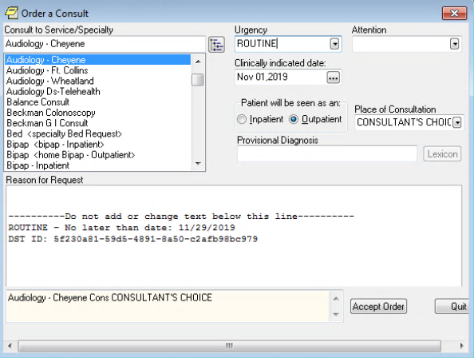

1. Click **Accept Order**. The consult is signed and actual DST information is displayed in the form of a comment. Any changes to DST after a consult is signed will result in a new comment.

Figure : Admin: DST Data Displayed in Consult Details

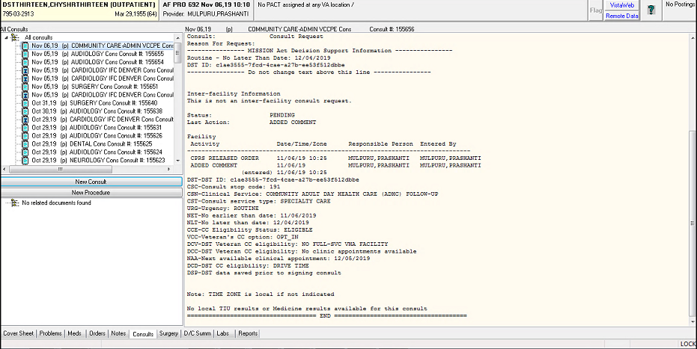

# Troubleshooting

## Unable to Lookup Clinical Service

Concurrent to the remote data calls, DST searches an internal table (updated nightly from CDW) to get the Clinical Service for the selected consult and sets the consult type to Primary Care/Mental Health (PC/MH) or Specialty Care based on government-provided mapping data. If the Clinical Service cannot be identified from the CDW tables, a message will be displayed in the VA facilities area to prompt the user to select the Clinical Service manually.

Figure 38: Manual Selection of Clinical Service

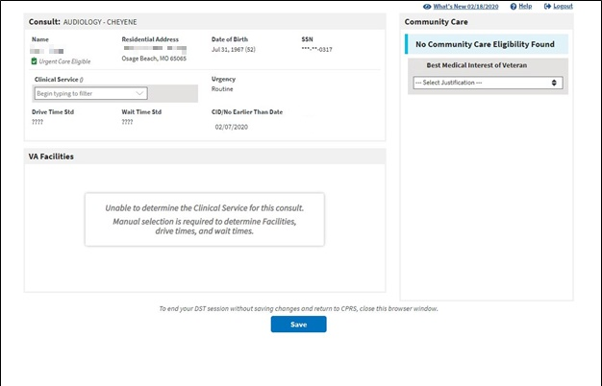

## MVI Error Handling

If MVI does not respond within 10 seconds or a single exact match ICN is not returned, an error message is displayed to the user, the error code is logged in the DST database, the rest of the remote data calls are skipped, and the user can continue with the DST workflow. The specific error code will be stored in the DST database and added to comments after consult is signed to support analytics/reporting.

Figure 39: Veteran Identity Error Handling

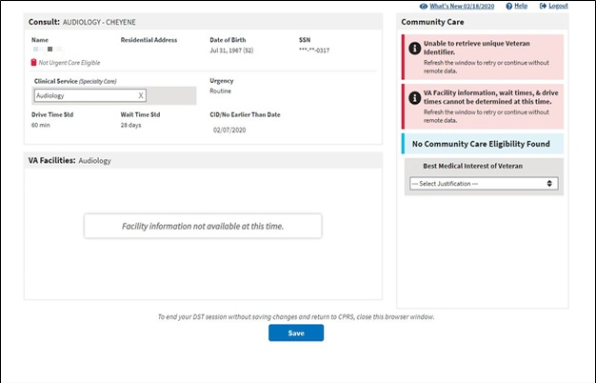

## Enrollment System (ES) Error Handling

If ES does not respond within 10 seconds or the Veteran ICN is not found, an error message is displayed to the user, the error code is logged in the DST database, the rest of the remote data calls are skipped, and the user can continue with the DST workflow. The specific error code will be stored in the DST database and added to comments after consult is signed to support analytics/reporting.

Figure 40: Veteran Eligibility Error Handling

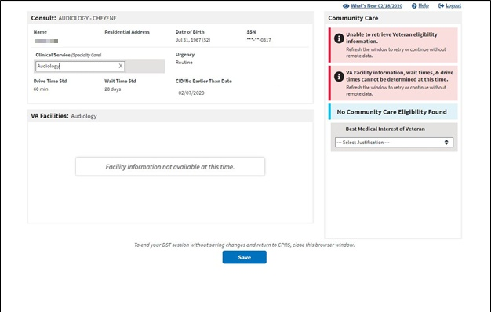

## PPMS Error Handling

If PPMS does not respond within 10 seconds an error message is displayed to the user in the VA Facilities section, the error code is logged in the DST database, Drive Time and Wait Time VCEs displayed with error icons, and the user can continue with the DST workflow. The specific error code will be stored in the DST database and added to comments after consult is signed to support analytics/reporting.

Figure 41: VA Facilities Error Handling

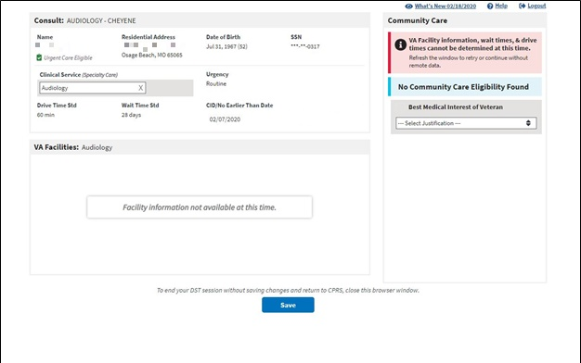

# Acronyms and Abbreviations

Table 2. Acronyms and Abbreviations

| Acronym | Definition |
| --- | --- |
| API | Application Program Interface |
| BMI | Best Medical Interest |
| CC | Community Care |
| CD2 | Critical Decision Point #2 |
| CDW | Corporate Data Warehouse |
| CHAMPVA | Civilian Health and Medical Program of the Department of Veterans Affairs |
| CID | Clinically Indicated Date |
| CITI | CHAMPVA In-house Treatment Initiative |
| CPRS | Computerized Patient Record System |
| DST | Decision Support Tool |
| EMR | Electronic Medical Record |
| ES | Enrollment System |
| ICN | Integration Control Number |
| ID | Identification |
| IFC | Inter-Facility Consults |
| MH | Mental Health |
| MVI | Master Veteran Index |
| OIT | Office of Information and Technology |
| PC | Primary Care |
| PII | Personally Identifiable Information |
| PPMS | Provider Profile Management System |
| SEOC | Standardized Episodes of Care |
| SSN | Social Security Number |
| SSOi | Single Sign On Integration |
| TBD | To Be Determined |
| VA | Department of Veterans Affairs |
| VCCP | Veteran Community Care Program |
| VCCPE | Veteran Community Care Program Eligibility |
| VDL | VA Software Document Library |
| VHA | Veterans Health Administration |
| VIP | Veteran-focused Integrated Process |
| VistA | Veterans Health Information Systems and Technology Architecture |